Suricat Website Redesign (Landing Page)

TOP BANNER:
Navigation BAR:
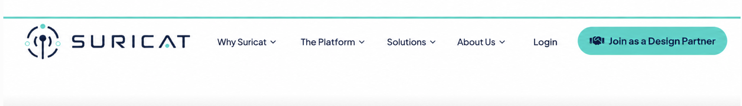

CTAs:
Only three CTAs
1) Join as a Design Partner
2) Request a Pilot
3) Talk to Us

Why Suricat Navigation Dropdown:
1) THE COST OF MISALIGNMENT 2) WHY THIS MATTERS NOW
3) THE ALIGNMENT GAP 4) BEYOND EXISTING SYSTEMS
5) BUILT FOR REGULATED ENVIRONMENTS 6) WHY SURICAT

Hero Section Message:

The Sentinel for Compliance Intelligence
Suricat is an AI-powered Compliance Intelligence platform that works alongside existing QMS and other quality systems to uncover potential compliance gaps, quality issues, and misalignments across documents and records. Every issue is traced to its source, helping QA/RA teams review and address it before it becomes a finding.

Hero Visual:
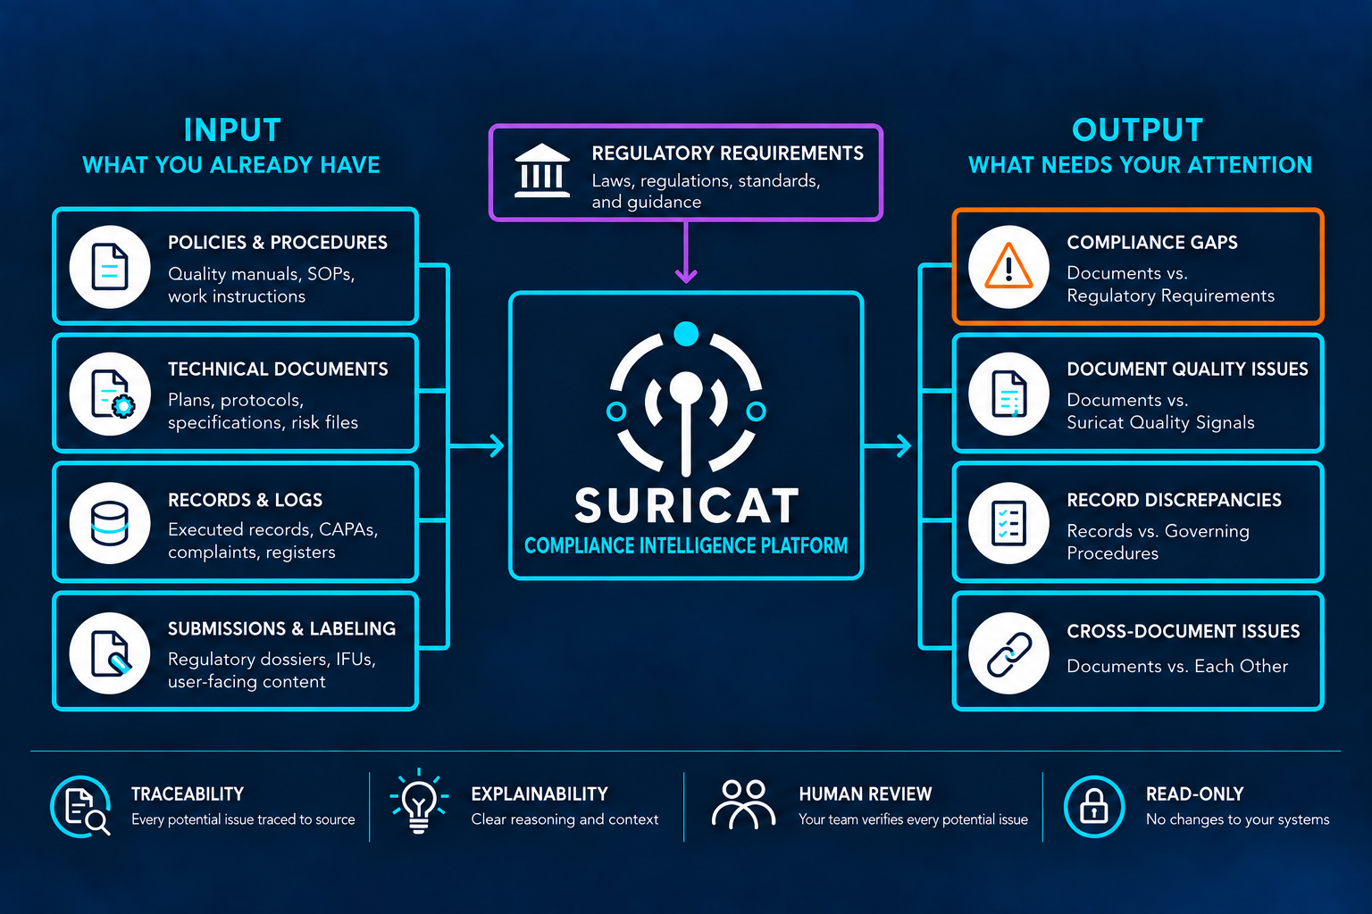

1) THE COST OF MISALIGNMENT (Make this in Teal)
Misaligned quality documents, procedures, and records can make it harder to identify gaps, reconcile evidence, and respond to regulatory scrutiny. FDA data reveals the broader challenges medical device manufacturers face, including inspection deficiencies, enforcement, additional information requests, and lengthy submission reviews.

74%
Major deficiencies flagged in nearly three of four completed high-risk device reviews
Source: FDA, FY2025 MDUFA Report to Congress

66%
Two in three completed 510(k) reviews required additional information
Source: FDA, FY2025 MDUFA Report to Congress

149 days
Manufacturer responses consume months of PMA review
Source: FDA, MDUFA Quarterly Report, Aug. 2026

26 of 59
Design controls and CAPA lead FDA quality-system enforcement
Sources:
Covington & Burling, Warning Letter Summaries: 2025 · 2024

279
CAPA procedures top FDA inspection observations
Source: FDA, FY2025 Inspection Observations

WHY THIS MATTERS NOW
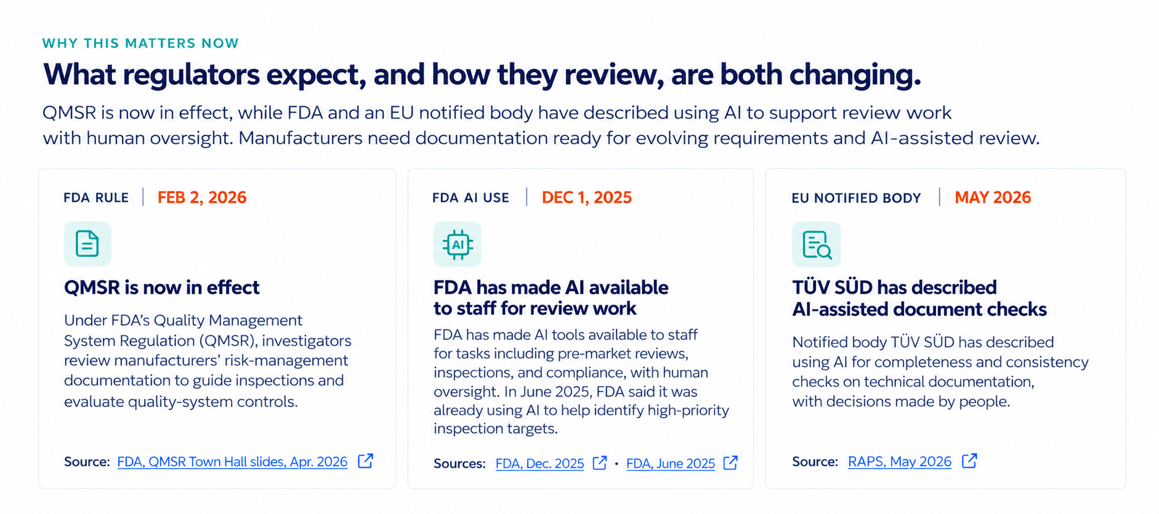

Card 1: FDA Rule, Feb 2, 2026
FDA, QMSR Town Hall slides, Apr. 2026
https://www.fda.gov/media/191961/download

Card 2: FDA AI Use, Dec 1, 2025
FDA, Dec. 2025
https://www.fda.gov/news-events/press-announcements/fda-expands-artificial-intelligence-capabilities-agentic-ai-deployment
FDA, June 2025
https://www.fda.gov/news-events/press-announcements/fda-launches-agency-wide-ai-tool-optimize-performance-american-people

Card 3: EU Notified Body, May 2026
RAPS, May 2026raps
https://www.raps.org/resource/euro-convergence-experts-share-insights-on-ai-for-submissions-conformity-assessments.html
2) THE ALIGNMENT GAP
Quality Systems Are in Place. Alignment Is the Hard Part.
Requirements change. Documents evolve. Evidence accumulates.
Quality system documents and records depend on one another, even across different systems.
When one changes, what else is affected?
The Alignment Gap Dynamic Visual:
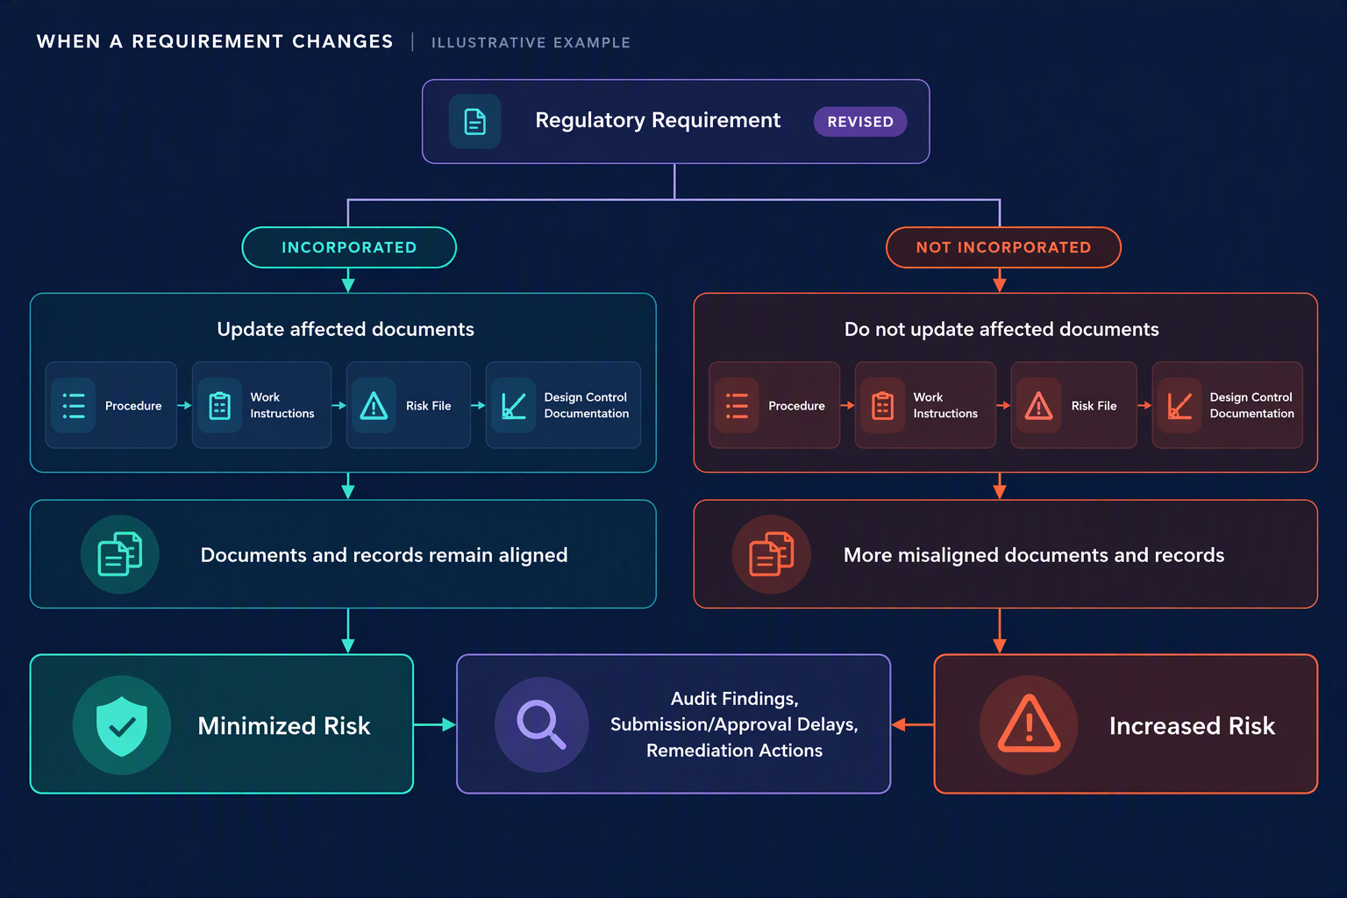
3) BEYOND EXISTING SYSTEMS

Existing Systems Manage the Information. Alignment Is Still the Challenge.

QMS and other quality systems manage documents, records, workflows, and approvals.

Compliance also depends on how that information relates to applicable requirements and to other documents and records.

Suricat works alongside those systems to surface where related information may no longer line up.

BEYOND EXISTING SYSTEMS Dynamic Visual

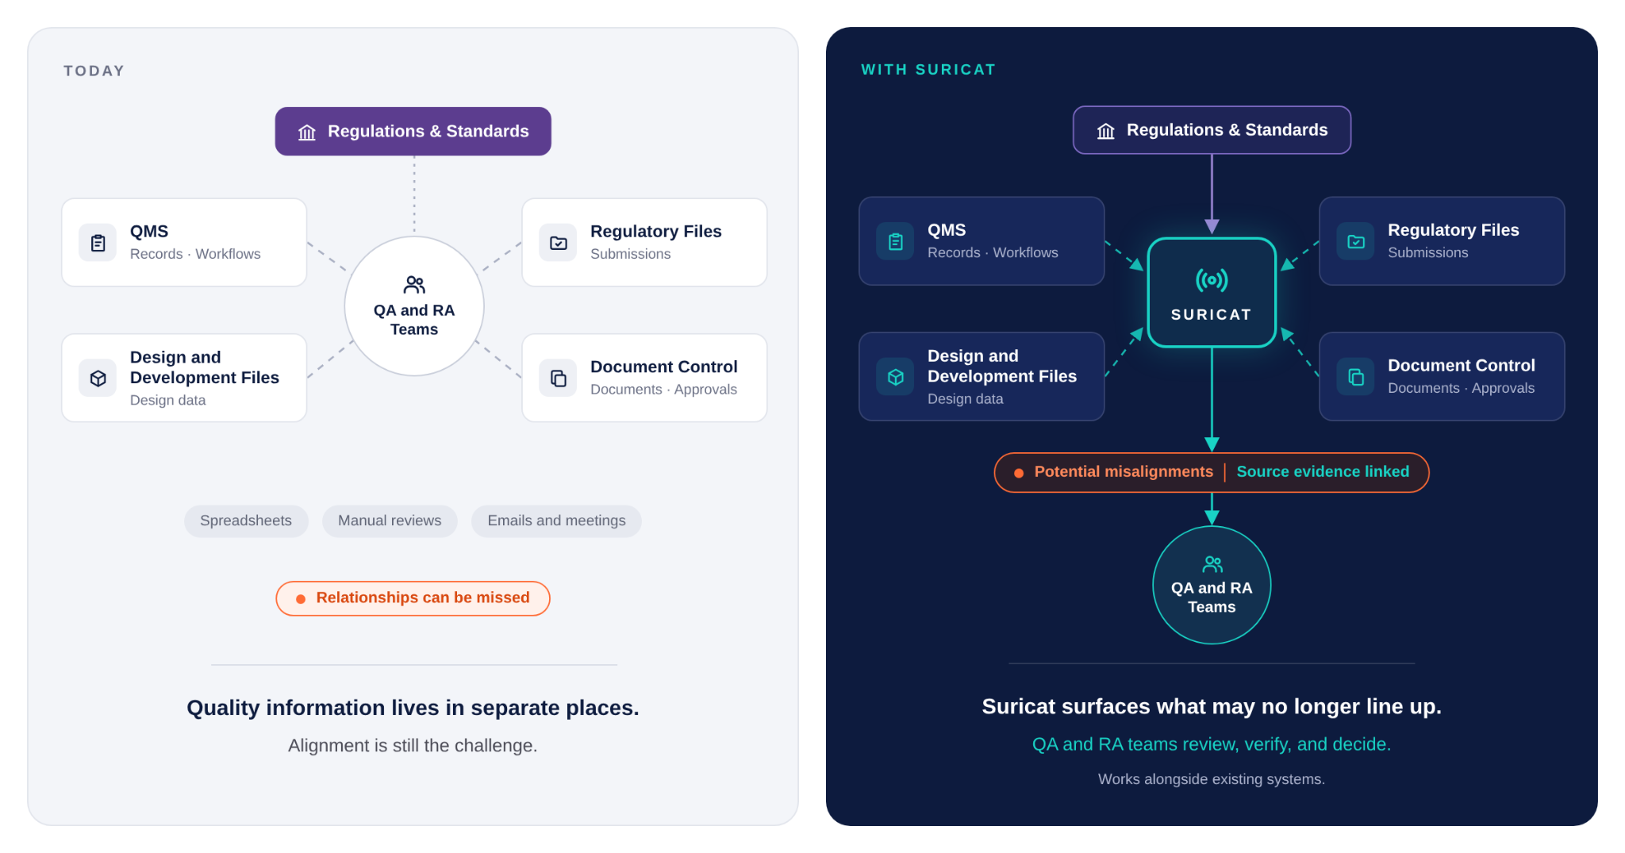

4) BUILT FOR REGULATED ENVIRONMENTS
Intelligence Without Giving Up Control.
Suricat fits into existing quality and regulatory environments while keeping QA and RA professionals in control.
Human Accountability
QA and RA professionals remain at the center of every review. Their expertise guides the assessment of potential issues and verification of evidence. They retain full authority over every decision and action.
No Rip and Replace
Existing QMS and document control systems stay in place. Suricat works alongside those systems and established processes.
Read Only by Design
Suricat evaluates compliance information without modifying controlled documents or source records. Existing approval processes and document controls remain intact.
Data Ownership
Customer data remains the customer’s property, is never used to train AI models, and is securely deleted following contract termination.
Isolated by Design
Each organization’s compliance information is isolated from other organizations’ data.
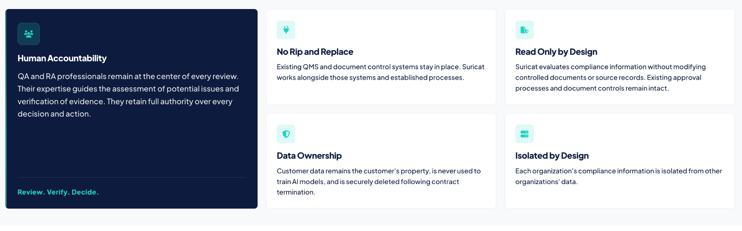

WHY SURICAT (CLOSING PUNCHLINE)
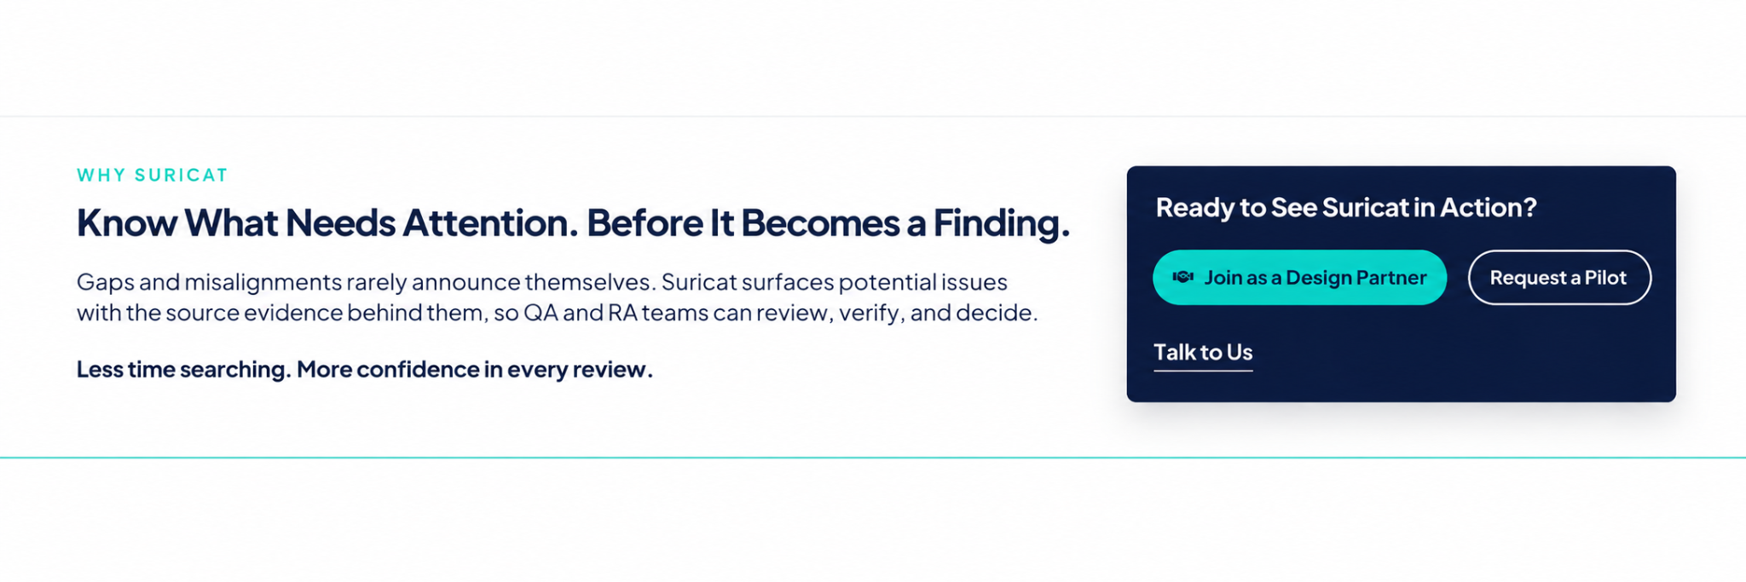
WHY SURICAT

Know What Needs Attention. Before It Becomes a Finding.
Gaps and misalignments rarely announce themselves. Suricat surfaces potential issues with the source evidence behind them, so QA and RA teams can review, verify, and decide.
Less time searching. More confidence in every review.

Ready to See Suricat in Action?
Join as a Design Partner Request a Pilot
Talk to Us
DESIGN PARTNER BAND
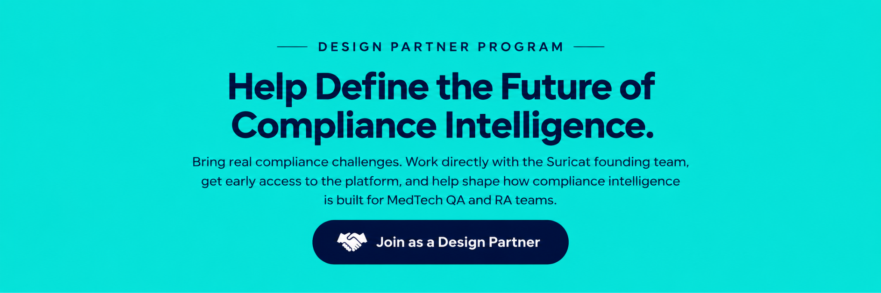

FOOTER

